Spread, Rest, and Concise Array Operations

**Instructions**

Close

**Lab instructions**

0 of 1 completed

JavaScript Essentials: Spread, Rest, and Concise Array Operations

​

**Introduction:**

In JavaScript, the spread (...) and rest (...) operators are powerful tools for handling arrays and function arguments. These operators simplify the process of working with collections, making your code more concise and readable. This lab introduces practical applications of these operators through hands-on exercises.

**Goal:**

* Separate elements from an array into individual items and subarrays using the spread operator.
* Handle an unknown number of function arguments using the rest operator.
* Merge two arrays into a single array using the spread operator.

**Objectives:**

By the end of this lab, learners will:

1. Understand and apply the spread operator (...) to arrays and other iterable structures.
2. Use the rest operator (...) to manage an unknown number of function arguments.
3. Combine multiple arrays into one using the spread operator.
4. Practice writing concise and dynamic JavaScript code.

**Problem Statement**

You will work on three tasks:

1. Separate elements from an array into individual variables and a subarray.
2. Use the rest operator in a function to handle an unknown number of arguments.
3. Merge two arrays into one using the spread operator.

**Instructions:**

**Part 1: Separate Array Elements**

**Step 1:**

* Navigate to the Spread_Rest folder under PROJECT folder and locate the **spread_operator.js** file.
* Open the file to view the provided code skeleton.

**Step 2:** Understand the concept of spread operator

Before diving into the task, let’s first understand what the spread operator (...) is and how it works in JavaScript.

The spread operator is used to expand elements of an array, object, or iterable into individual items. It’s represented by three dots (...). For arrays, it allows us to easily extract or spread values, making operations like splitting arrays or merging arrays simpler.

Here’s an example of the spread operator:

1

2

3

4

5

6

7

const numbers = [1, 2, 3, 4, 5];

const [first, second, ...remaining] = numbers;

console.log(first); // Output: 1

console.log(second); // Output: 2

console.log(remaining); // Output: [3, 4, 5]

In this example:

* first gets the value 1.
* second gets the value 2.
* remaining is assigned the rest of the elements as a subarray [3, 4, 5].

**Step 3:** Understand the Provided Array Structure

**Initial Code (spread_operator.js)**

* You will find a topSixRestaurants array like this:

1

const topSixRestaurants = ["Chick-fil-A", "In-N-Out", "Chipotle", "McDonald's", "Taco Bell", "KFC"];

**Step 4:** Destructure and Print Array Elements

1. Extract Elements Using the Spread Operator

Use the spread operator to destructure the topSixRestaurants array into:

* The first three elements assigned to variables: first, second, third.
* The remaining elements grouped into a subarray: remaining.

2. Print the Values

Use console.log to print each variable and the subarray in the following format:

1

2

3

4

console.log(`First restaurant: ${first}`);

console.log(`Second restaurant: ${second}`);

console.log(`Third restaurant: ${third}`);

console.log(`Remaining restaurants: ${remaining}`);

**Step 5:** Execute the program by clicking the play button displayed below.

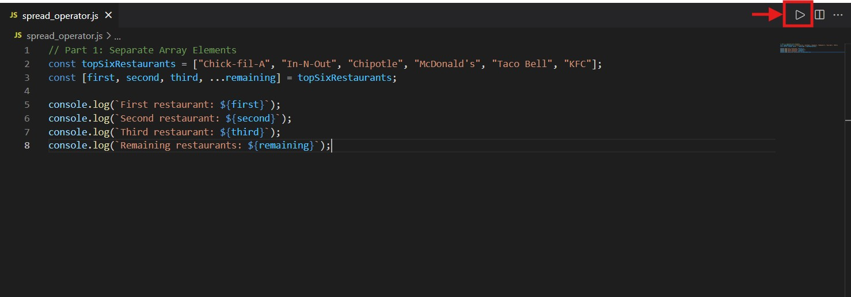

**step 6 :** After running the code, the output will be displayed as shown below

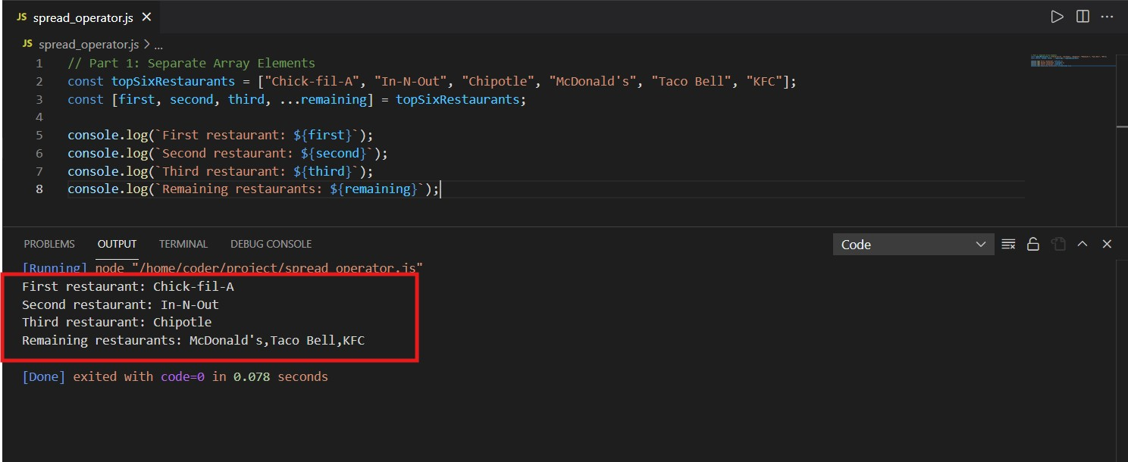

**solution**

**Note:** Before looking the given solution, it is highly recommended to try writing the code yourself based on the hints that are provided and concepts you have learned.

1

2

3

4

5

6

7

8

// Part 1: Separate Array Elements

const topSixRestaurants = ["Chick-fil-A", "In-N-Out", "Chipotle", "McDonald's", "Taco Bell", "KFC"];

const [first, second, third, ...remaining] = topSixRestaurants;

console.log(`First restaurant: ${first}`);

console.log(`Second restaurant: ${second}`);

console.log(`Third restaurant: ${third}`);

console.log(`Remaining restaurants: ${remaining}`);

**Part 2: Handle Unknown Function Arguments**

**Step 1:**

* Navigate to the Spread_Rest folder under PROJECT folder and locate the **rest_operator.js** file.
* Open the file to view the provided code skeleton.

**Step 2:** understand the concept of rest operator

The **rest operator** (...args) in JavaScript allows you to gather all remaining arguments of a function into a single array. This is particularly useful when working with functions that accept an unknown or variable number of arguments.

In the function definition, the ...args syntax is used to collect all additional arguments passed to the function into an array.

Example:

1

2

3

4

5

function unknownArgs(...args) {

    console.log(args);

}

unknownArgs(1, 2, 3, 4);

// Output: [1, 2, 3, 4]

Here, all the arguments (1, 2, 3, 4) are collected into the args array.

**Step 3:** Understand the Provided Array Structure

1. In the **rest_operator.js** file, you will find an incomplete unknownArgs function

1

2

3

function unknownArgs(...args) {

    // Your code here

}

**Step 4:** Iterating and Testing the **unknownArgs** Function

1. Modify the function to iterate over args using a for loop and print each argument.

2. Test the function with various sets of arguments, such as numbers and strings, as shown below

1

2

unknownArgs(1, 2, 3, 4, 5);

unknownArgs("a", "b", "c");

**Step 5:** Execute the program

* Follow the same steps outlined in Step 5 of Part 1.

**step 6 :** After running the code, the output will be displayed as shown below

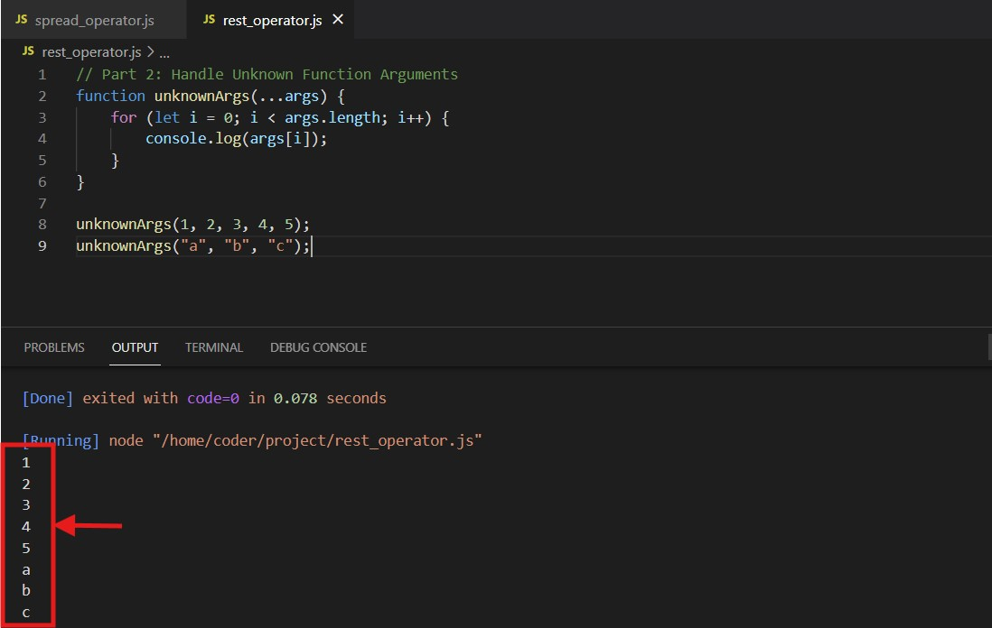

**solution**

**Note:** Before looking the given solution, it is highly recommended to try writing the code yourself based on the hints that are provided and concepts you have learned.

1

2

3

4

5

6

7

8

9

// Part 2: Handle Unknown Function Arguments

function unknownArgs(...args) {

    for (let i = 0; i < args.length; i++) {

        console.log(args[i]);

    }

}

unknownArgs(1, 2, 3, 4, 5);

unknownArgs("a", "b", "c");

**Part 3: Merge Arrays**

**Step 1:**

* Navigate to the Spread_Rest folder under PROJECT folder and locate the **merge_array.js** file.
* Open the file to view the provided code skeleton.

**Step 2:** Understand the Provided Array Structure

1. In the **merge_array.js** file, you will find two arrays

1

2

const favoriteBaseballTeams = ["Yankees", "Mets", "Dodgers", "Giants", "Red Sox", "Cubs"];

const favoriteFootballTeams = ["Patriots", "Giants", "Jets", "Eagles", "Steelers", "Cowboys"];

**Step 3:** Merging Arrays Using the Spread Operator

1. Use the **spread operator** to merge these two arrays into a single array called **favoriteTeams**.
2. Print the **favoriteTeams** array to verify the output.

**Step 4:** Execute the program

* Follow the same steps outlined in Step 5 of Part 1.

**Step 5 :** After running the code, the output will be displayed as shown below

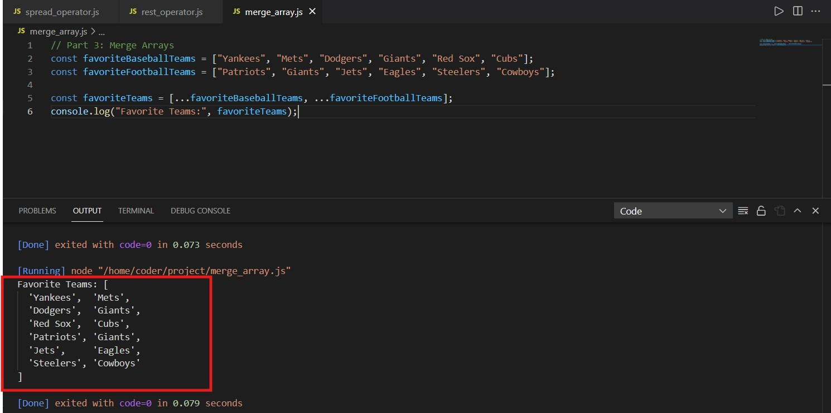

**solution**

**Note:** Before looking the given solution, it is highly recommended to try writing the code yourself based on the hints that are provided and concepts you have learned.

1

2

3

4

5

6

// Part 3: Merge Arrays

const favoriteBaseballTeams = ["Yankees", "Mets", "Dodgers", "Giants", "Red Sox", "Cubs"];

const favoriteFootballTeams = ["Patriots", "Giants", "Jets", "Eagles", "Steelers", "Cowboys"];

const favoriteTeams = [...favoriteBaseballTeams, ...favoriteFootballTeams];

console.log("Favorite Teams:", favoriteTeams);

**Key Takeaways:**

1. Array Destructuring with the Spread Operator

* The spread operator (...) simplifies breaking down arrays into individual variables and subarrays.
* It enhances code readability and eliminates the need for manual slicing.

2. The Rest Operator in Functions

* The rest operator (...args) enables functions to handle an unknown number of arguments dynamically.
* It gathers multiple arguments into an array, making iteration and manipulation straightforward.

3. Merging Arrays with the Spread Operator

* The spread operator (...) provides a clean and concise way to merge multiple arrays into a single array.
* It avoids the need for loops or manual concatenation.

4. Practical Application of ES6 Features

* These modern JavaScript features simplify common programming tasks, making code shorter, cleaner, and more intuitive.

**Final Step: Mark as Completed**

* Click the **Mark as Completed** button present below to mark the lab as **Completed.**